**22AIE115 – USER INTERFACE DESIGNING**

**GROUP 9**

|  |  |
| --- | --- |
| **Student Name** | **Roll Number** |
| Ashwin Sasi | AM.EN.U4AIE22007 |
| Anuvind MP | AM.EN.U4AIE22010 |
| Harishankar Binu Nair | AM.EN.U4AIE22023 |
| RS Harish Kumar | AM.EN.U4AIE22042 |

# **1. Project Summary**

Our project focuses on developing a secure website/web application for code management and collaboration. It includes features like user authentication, repository management, collaboration tools, a user-friendly interface, and efficient search capabilities. The aim is to provide developers with an intuitive platform to effectively manage their code, collaborate with team members, and enhance productivity.

## **1.1 Project Overview**



**– A code sharing & collaborating platform**

**Overview:**

## Our User Interface project streamlines code collaboration, version control, and team coordination for development teams. By providing an intuitive UI, it simplifies code reviews, pull requests, and issue tracking, enhancing productivity and code quality. With streamlined processes, our project enables seamless collaboration.

## **1.2 Project Scope**

Our project aims to develop a web application that offers a secure platform for collaborative code management and version control, catering to the needs of developers.

**The key features include:**

* **User Authentication:** A secure login system where users can create accounts, log in with their credentials, and manage their profiles within the platform.
* **Repository Management**: Allow users to create repositories, organize their codebase, and perform essential operations such as file navigation and editing.
* **Code Editor/Text editor:** Allows users to write and test code without installing any software locally. It is used for quick prototyping.
* **Collaboration and Communication:** Provide features that foster collaboration among users, including code reviews, pull requests, and discussion forums, facilitating effective communication and teamwork.
* **User-Friendly Interface:** An intuitive and user-friendly interface that enhances the user experience, ensuring ease of use and seamless navigation within the platform.
* **Search and Discovery:** A powerful search functionality to enable users to easily find repositories, project files, and relevant code snippets, improving efficiency in code discovery.
* **Chat:** A user-intuitive chat that helps users communicate with other users to create and build projects.
* **Dark/Light mode:** User can switch between Light mode & Dark mode.

Our project includes implementing secure user authentication and repository management. Additionally, we'll create collaboration features, a user-friendly interface, and powerful search capabilities to enhance teamwork, navigation, and code discovery within the platform.

## **2.0 General Description**

## **2.1 Product Functions Overview**

**Types of users**

1. **Admin/owner**
2. **Developer/Team member**
3. **Project manager**

1. Admin/owner features :

Has full control over the application and can manage all aspects of the system, including user roles and permissions, project settings, and administrative tasks

2. Developers/Team member features :

* The primary users of the application
* Can create, edit, and collaborate on code, submit pull requests, review code changes, and track issues related to the project.

3. Project manager features :

* Responsible for overseeing the progress of the project and managing the development team
* Can assign tasks to team members, track the status of tasks, and monitor the overall project timeline

## **2.2 User interface Design**

* *We made the designs using Figma*

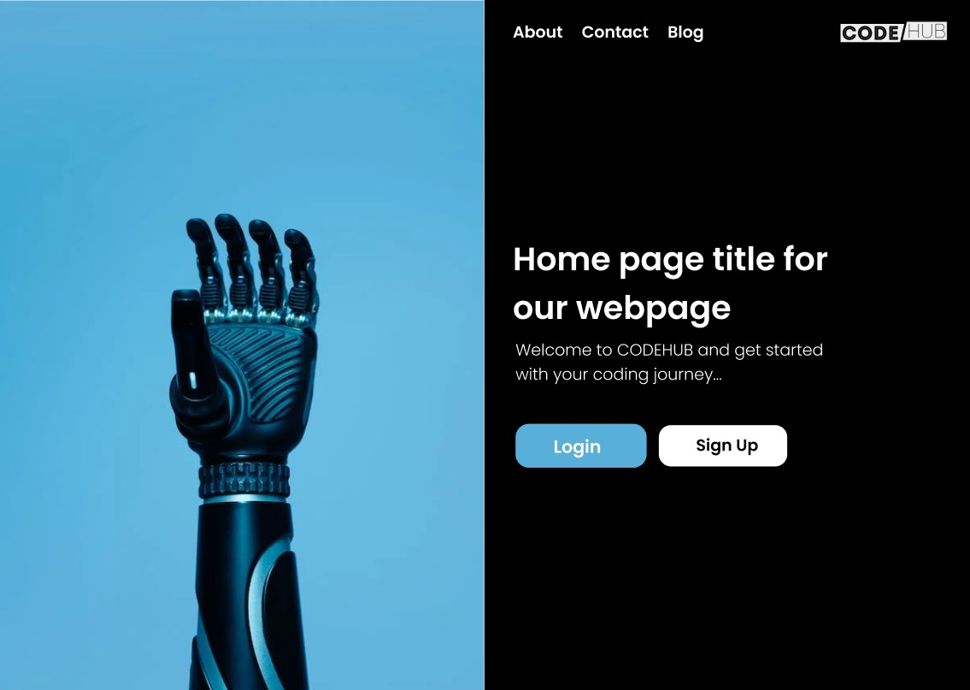

**Starting Page**

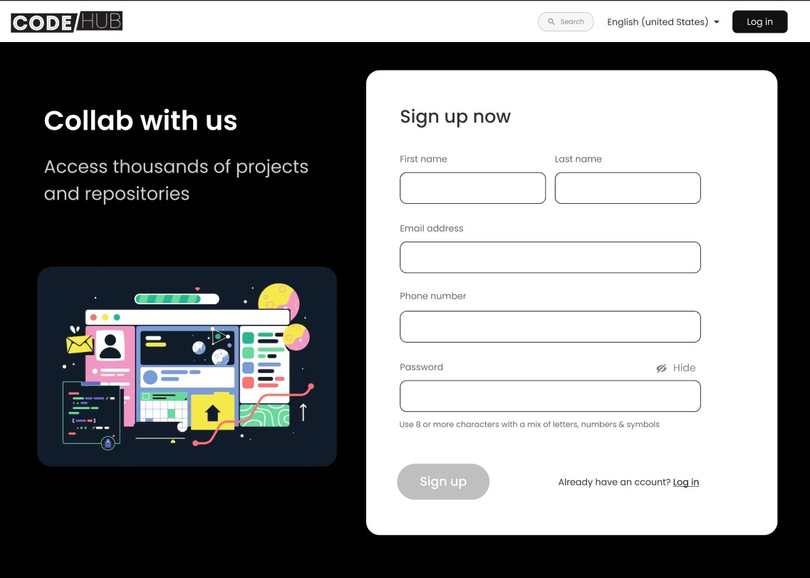

**Sign up page**

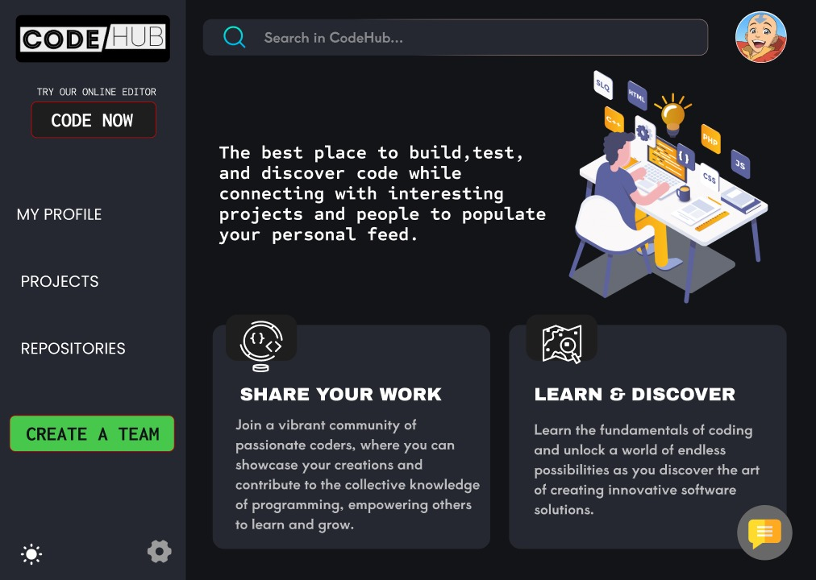

**Home page**

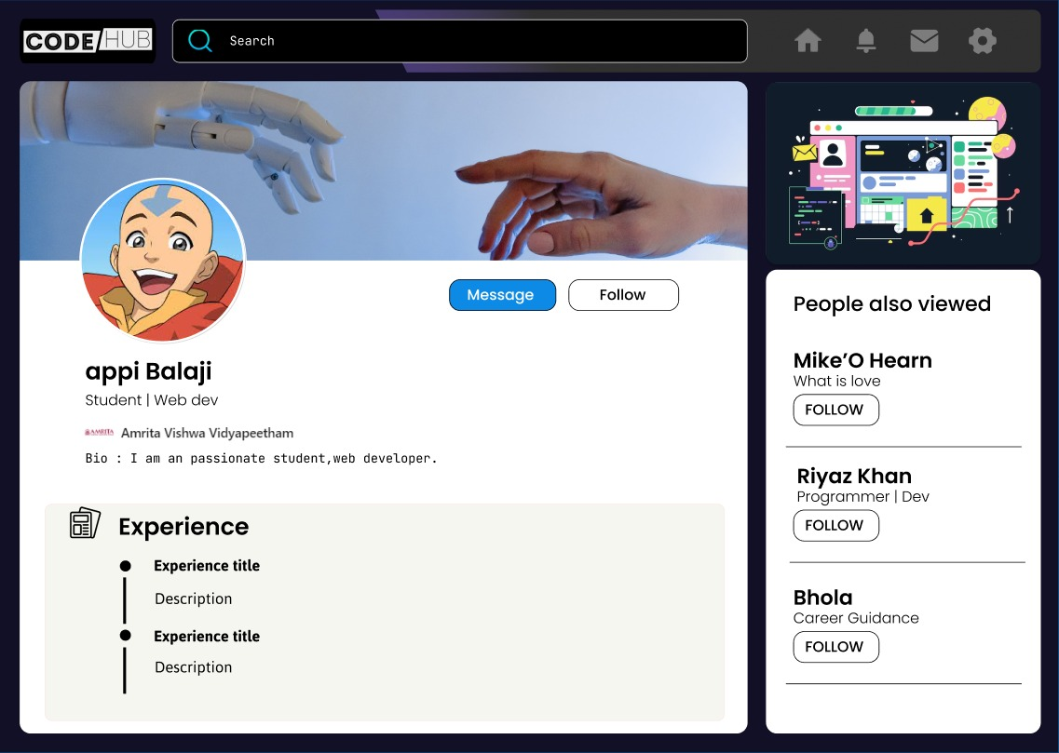

**User profile/dashboard**

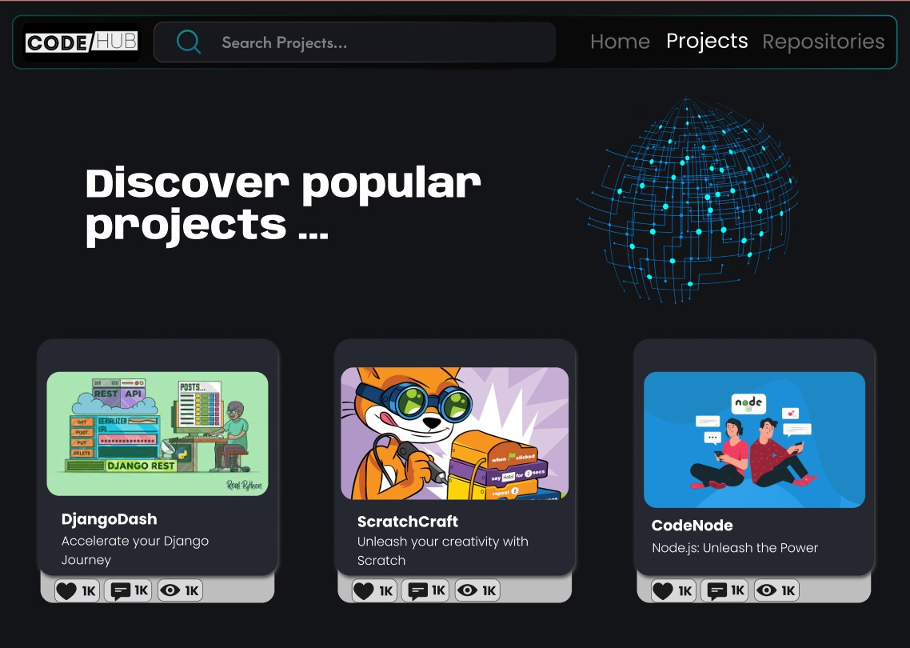

**Project Page**

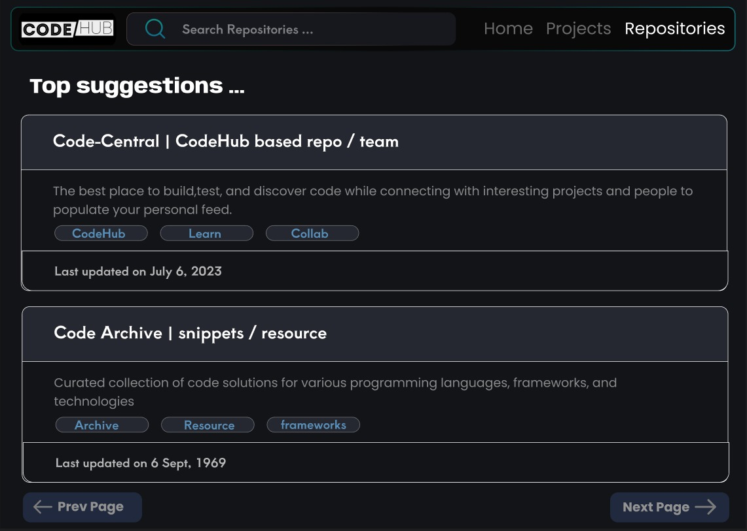

**Repository Page**

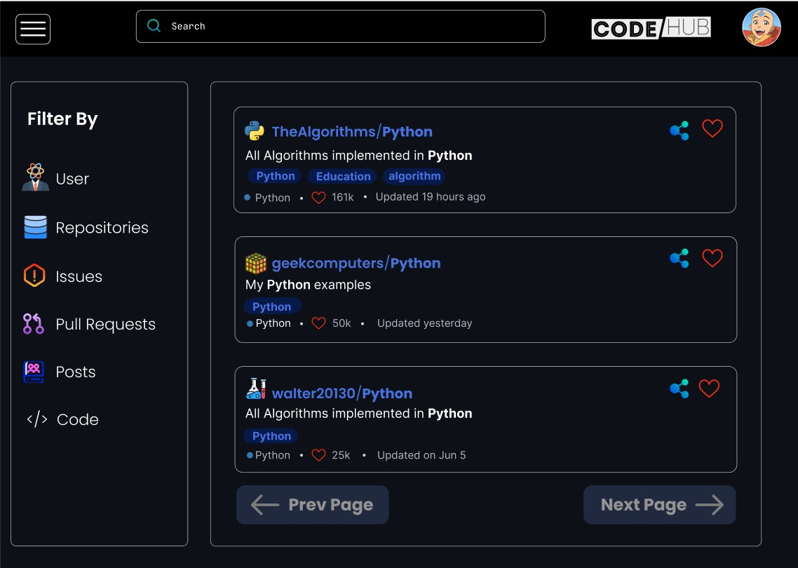

**Search Results Page**

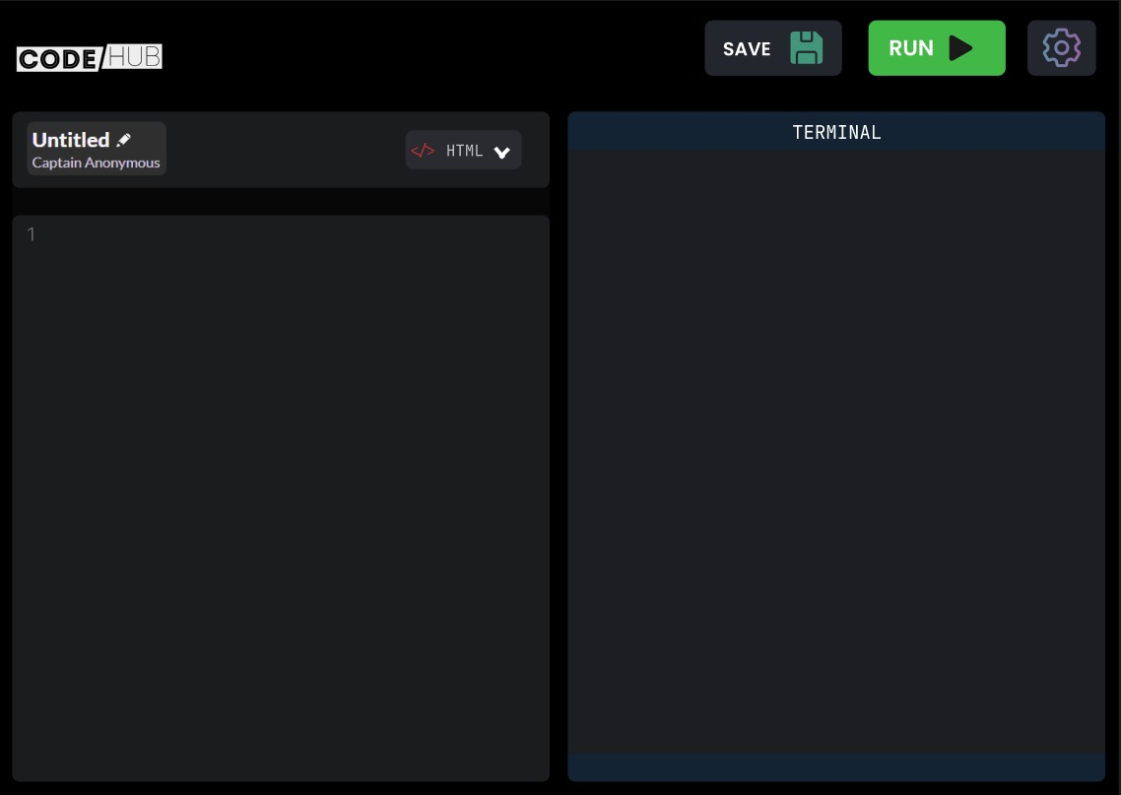

**Code Editor**

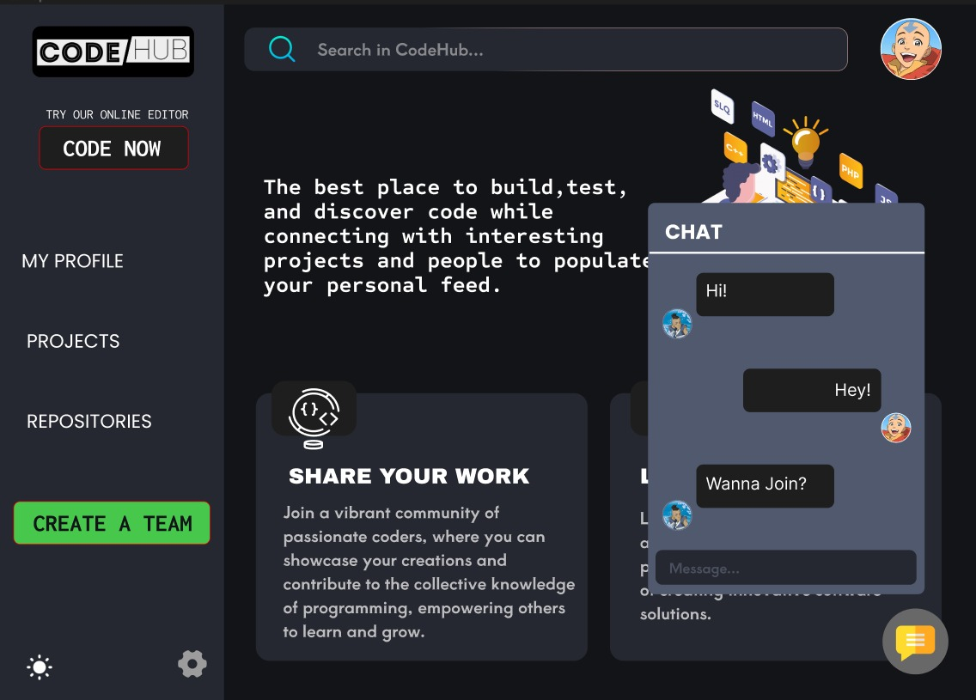

**Chatting with other users**

**2.3 Link to the developer’s website**

1. Anuvind MP (AM.EN.U4AIE22010)

Link: [portfolio & resume](https://amritauniv-my.sharepoint.com/:f:/g/personal/am_en_u4aie22010_am_students_amrita_edu/EnvgfGuDRY1PnApFt8Q0J6UBAPXV14GPIIt0XMTUGVqvpg?e=hhZmZf)

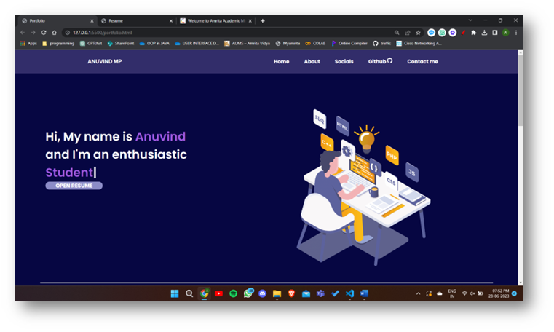



1. Ashwin Sasi (AM.EN.U4AIE22007)

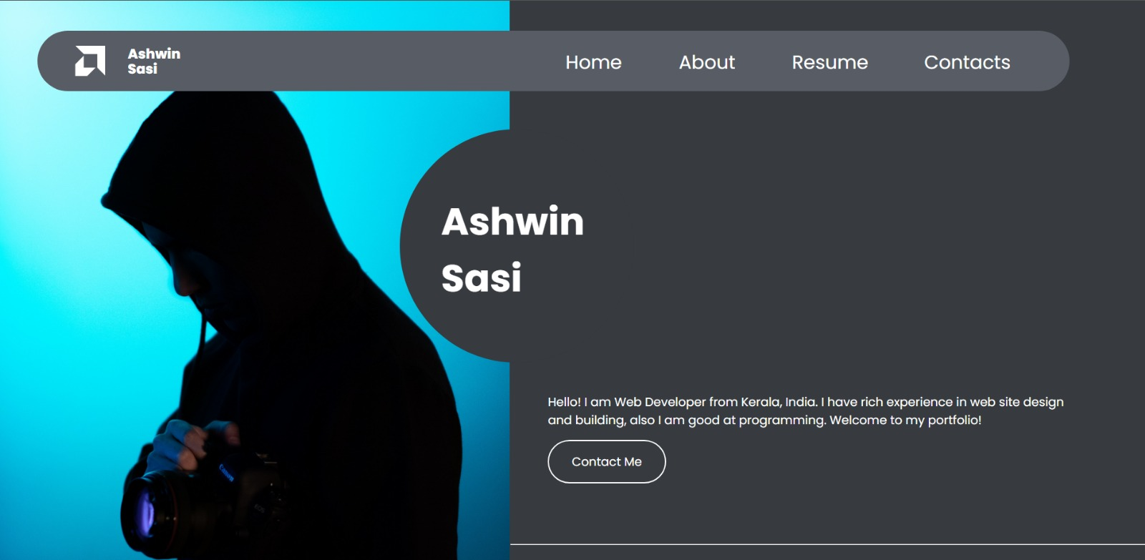Link: [Portfolio](https://amritauniv-my.sharepoint.com/:f:/g/personal/am_en_u4aie22007_am_students_amrita_edu/Eo1VIXgncqNKiN_8c2fgLu4B4e5wcF0GlBq4Rq-_sOJSWQ?e=Fhn9fD)

1. Harishankar Binu Nair (AM.EN.U4AIE22023)

Link: [UID Proj](https://amritauniv-my.sharepoint.com/:f:/g/personal/am_en_u4aie22023_am_students_amrita_edu/EsVa0P8uknFMhX0N8QLUfNkBN-LhuD2Gs4I6JzFqHyfwfA?e=1564A7)

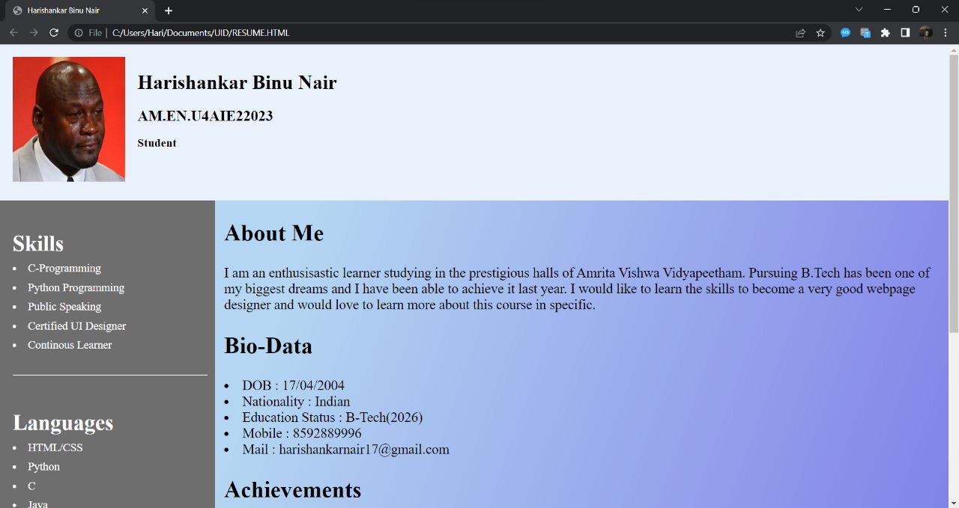

1. R S Harish Kumar (AM.EN.U4AIE22042)

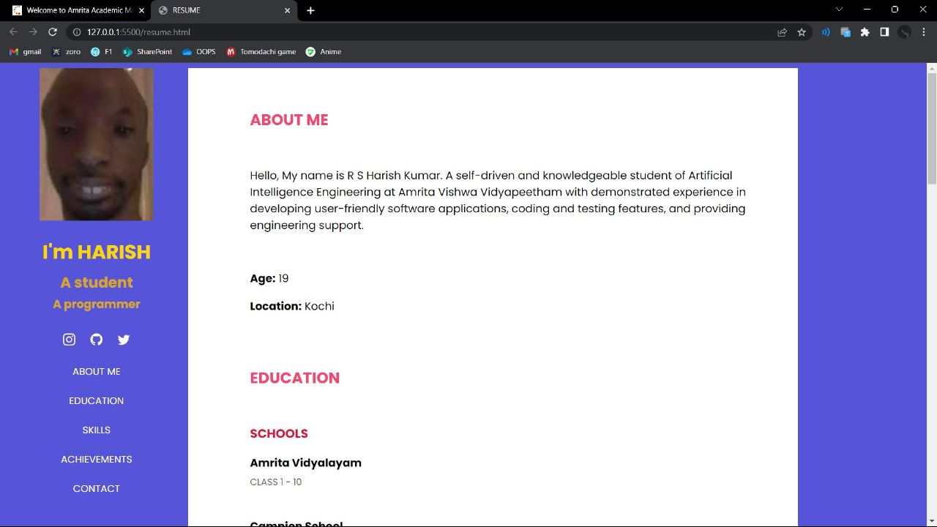Link: [Resume](https://amritauniv-my.sharepoint.com/:f:/g/personal/am_en_u4aie22042_am_students_amrita_edu/EvEiPQnnzU9Lr6ASRXqRQIQBw4gjNInTGZHfTCXALRUMFg?e=TkguKd)